https://chatgpt.com/s/t_691ac7429ef88191a99749a9d85e7c34
- YOLOv5 uses Focus layer, then CSPDarknet, and finally SPPF
- YOLOv8 doesn’t have Focus layer. Instead, it uses standard conv layer with SiLU activation function. This is simpler, faster, and more compatible with modern hardware.
- YOLOv5 uses C3 blocks whereas YOLOv8 uses C2f blocks.
- Both use the same SPPF

https://www.youtube.com/watch?v=HQXhDO7COj8
- Building blocks of YOLOv8
- 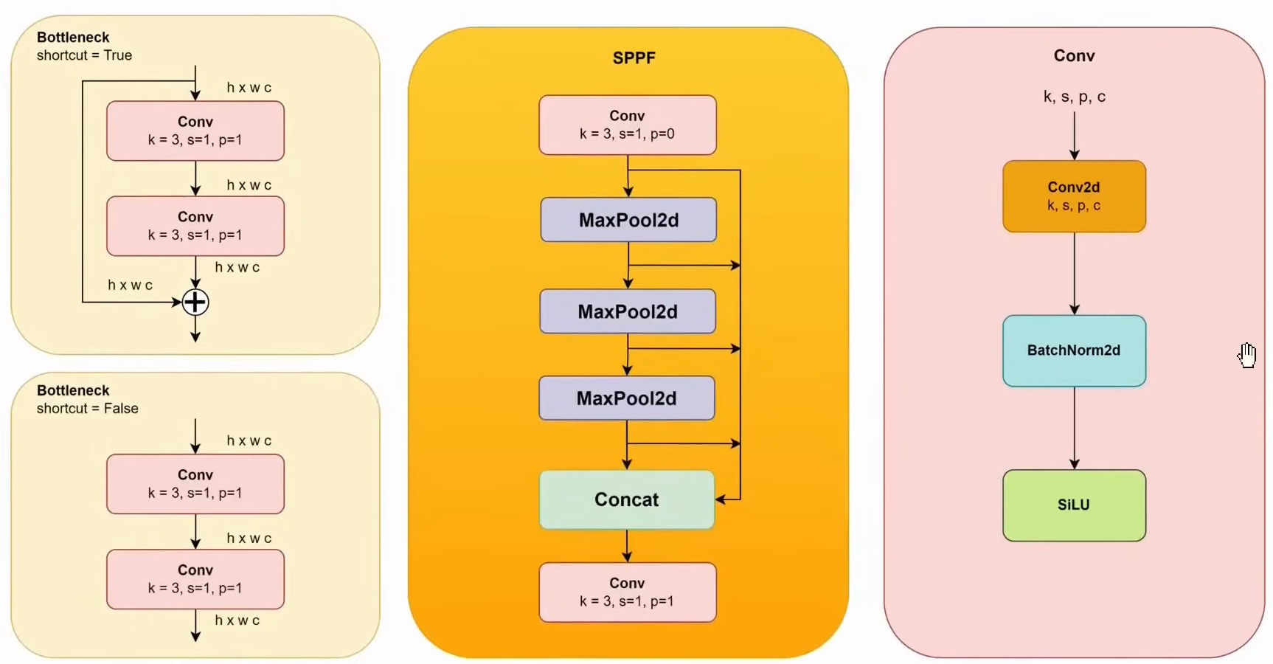
- 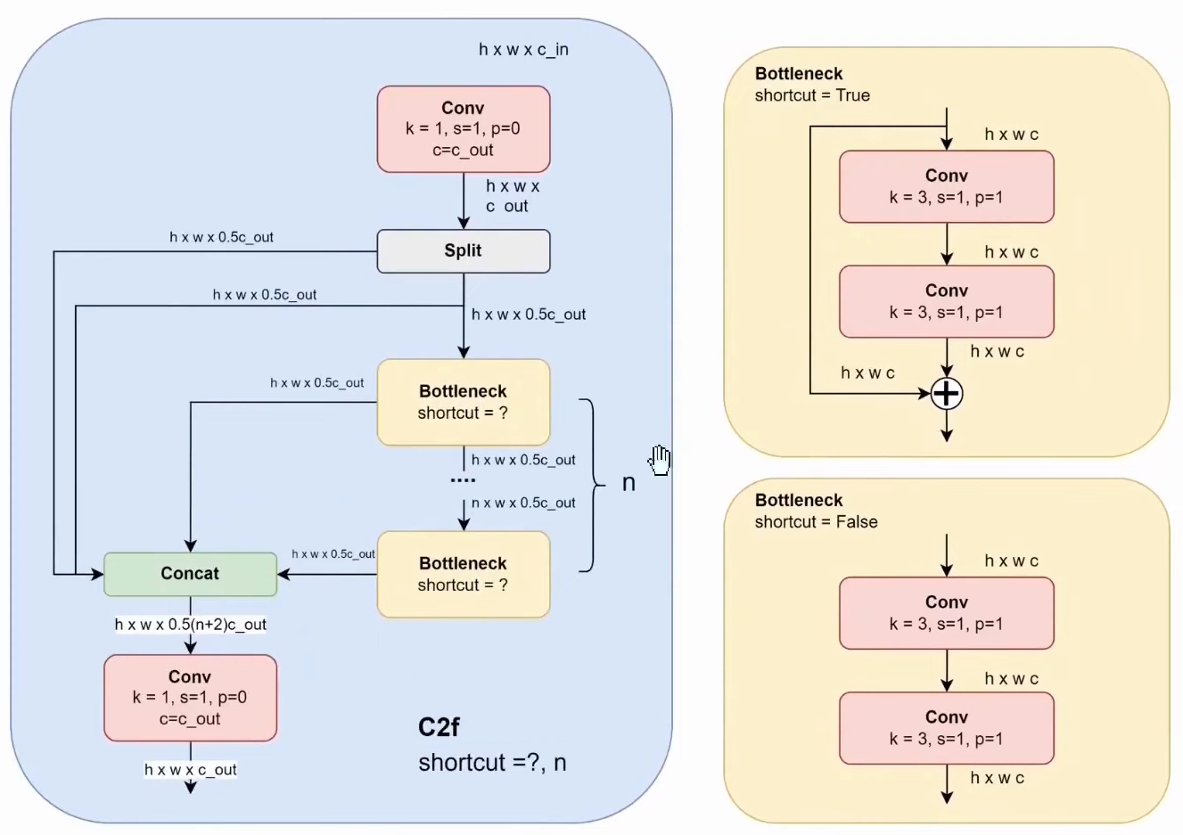
- 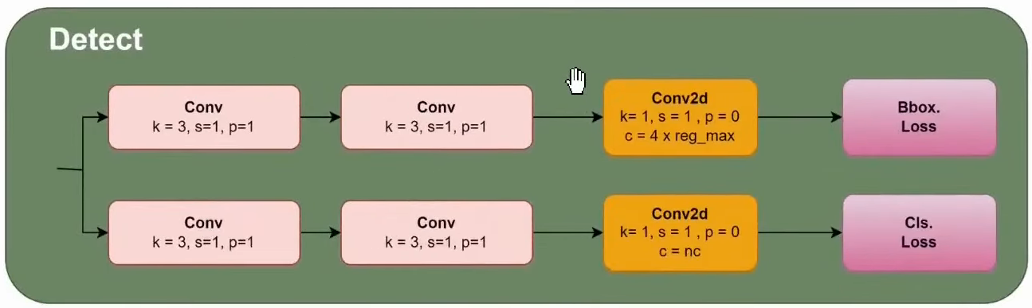
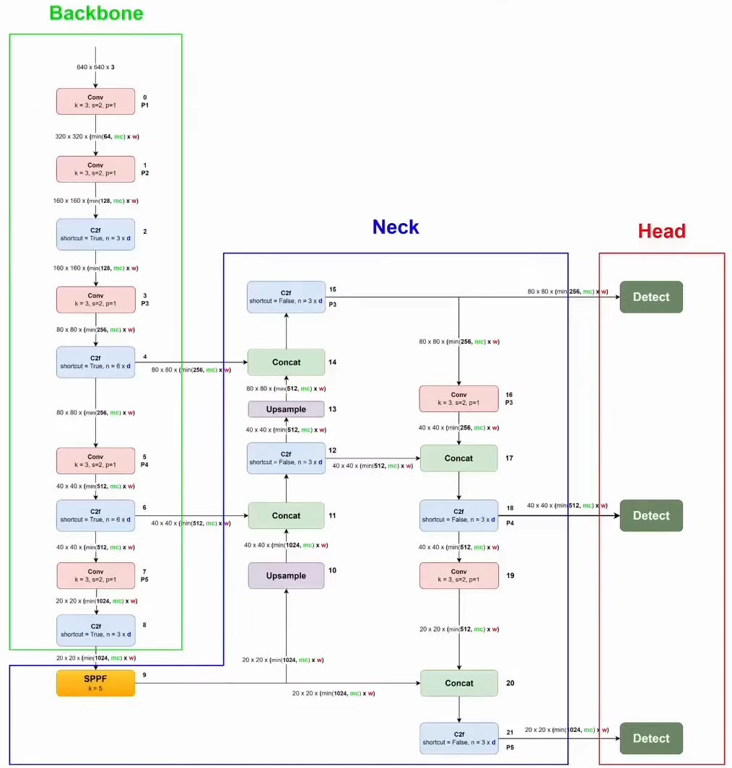
Input: 640*640*3
Conv blocks in backbone: k=3, s=2, p=1 halve spatial dimensions and double number of channels; first conv block outputs 64 channels
C2f blocks in backbone: shortcut=True; no change in spatial dimensions as well as number of channels
Bottleneck: two conv blocks with k=3, s=1, p=1; shortcut=True for bottlenecks in backbone and False for those in neck
Backbone: conv (Conv C2f) (Conv C2f) (Conv C2f) (Conv C2f)
The highlighted C2f blocks’ output is passed to FPN. The last C2f block’s output is first passed through SPPF before passing it to FPN.
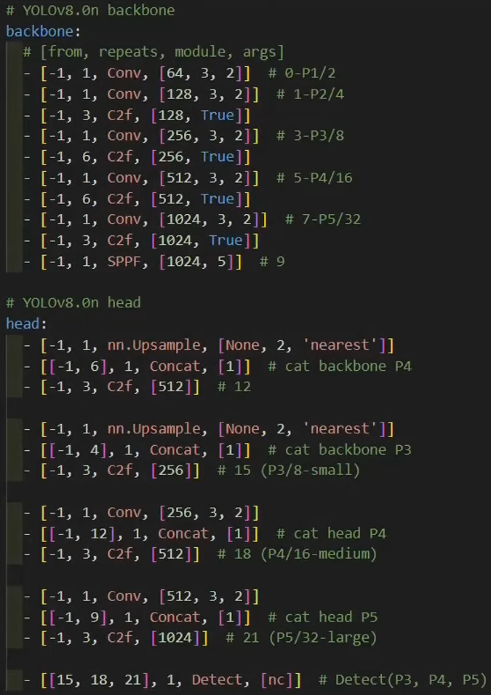

https://github.com/ultralytics/ultralytics/issues/189
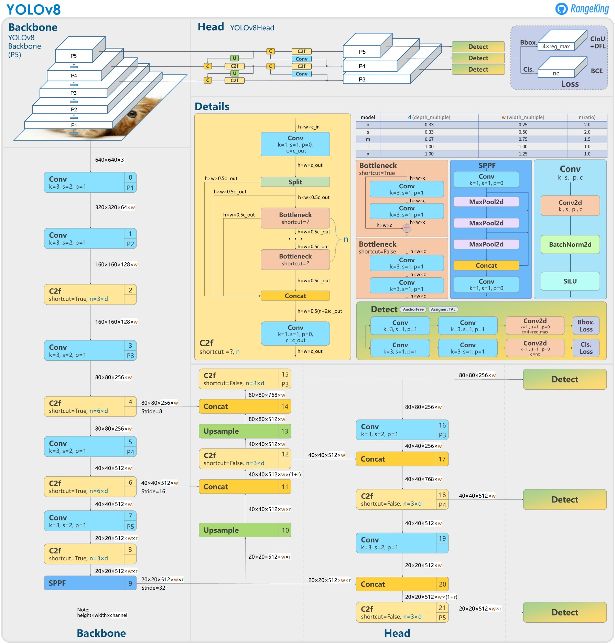
Check architecture image here

